During my mathayom 4-6 years, I felt like I had the most miserable life out of all my peers. My grades were dropping, I was failing almost every subject, my test scores were terrible, and I got into university almost later than everyone else in class. I also lash out whenever things go wrong and that made my friends distance from me even further. I considered myself to be a loser and just a person who’s good at nothing. And sometimes, I still feel like that. I’m Avarin Manupheeraphan, nickname Yoku, and this is my story.

I was born in Bangkok, Thailand, but I was raised in Nonthaburi for my entire life. I attended Panyapiwat Institute of Management Demonstration School, also known as Satit PIM during lower secondary school (Mathayom 1-3). Then I moved to Yothinburana School, enrolled in an English Program for the rest of my school years. My tuition fees ever since kindergarten have been very high, my family used to struggle financially, but they managed to pay all of my tuition fees.

I decided to pursue a degree in PGS because of how the seniors treated me nicely like I’ve always been their friends, and I’m also interested in the curriculum and activities that are offered here. Another reason is because I want to redeem myself as I’ve been burdened with guilt for my actions on how I always get mad and never apologized, along with how I was filled with selfishness and jealousy. which made me feel like my friends were holding grudges against me. I believe that coming to PGS could change me as a person, in terms of academics and mentality.

And I want to turn my misery into something positive, where everyone else doesn't feel negative because of my presence. As I’m slowly building my confidence up again, my dream is to become a diplomat or work in the United Nations, and I want to be the first person in my family to work in that field. I believe that I can achieve power with that job, as a contrast to how I was treated when I was younger, used as an advantage for others, but when I’m not used, I’m seen as weak and useless. Though I will not abuse that power for my own wants and needs, I will try to use that power of mine to help for the greater good once I achieve it. I know that the road up ahead is still far away from where I am now, but I am not the type of person to give up easily. I will do my best to achieve my goal, as my dream is never out of reach.

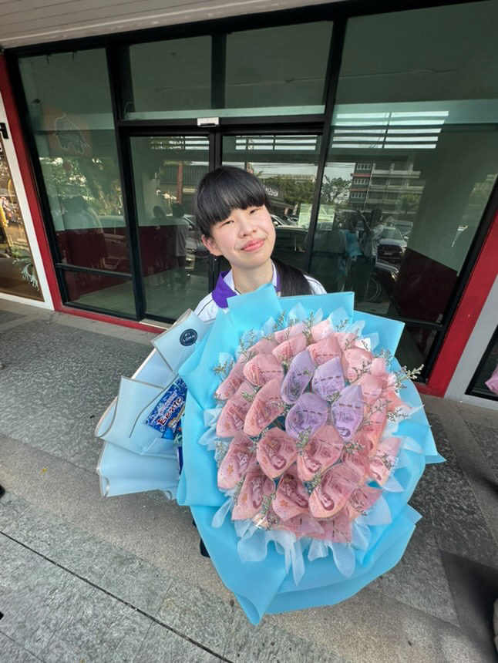

Avarin Manupheeraphan (Yoku), Student ID 6848057624

My name is Parnika, and I was born and raised in Bangkok, Thailand. For kindergarten and primary, I attended Thawsi School and later continued my secondary education at Satit Prasanmit International Programme. In school, I was fortunate enough to study in schools that gave me a variety of experiences both inside and outside of the classroom.

For the times I've had in the different schools, those experiences taught me different things. DUring my primary school years, I participated in a wide range of activities both inside and outside the classroom. My primary school emphasised hands-on learning methods rather than only traditional in-class lessons. This gave me a chance to be curious and engage in different areas from sports to creative activity. This environment helped me develop openness and courage to try new things, most importantly the understanding that we can also learn through experiences which are the qualities that have stuck with me as I grow older. In secondary school I focused heavily on subjects like science and mathematics. At first it felt like a natural path for me since I was comfortable with the structure and concept of those subjects. As the year went by, I began to realise that although I could manage the subject well, they did not feel special to me. There wasn't any sense of fulfilment that I felt then I slowly realised that this is not what I wanted for my future. That realisation was frightening, but it was important as it pushed me to look beyond what felt comfortable and consider another direction even though it could challenge me.

When it came time to decide what to study in university, I had a tough time making the decision. To be honest, my interest in political and global study does not come from my curiosity within the subject itself but rather from the opportunities it could create for me. I have always taken an interest in business, but I realise that in today's world, understanding the global systems and politics is the foundation of everything including business. What led me to study at PGS may not have been that I'm fascinated by the subject itself but the program that teaches students to understand from the ground up and think critically from a strong foundation. I appreciate that encouragement brought perspective and deeper analysis, skills that I believe are essential no matter what career path I eventually decide to pursue.

Ultimately I see PGS as the right step for me not only in terms of career preparation but also as a pathway to personal growth. I hope that I could build upon things I've learned from experiences I have up until now. What I hope to gain from this program is not only academic knowledge but also the ability to connect ideas across fields and learn from multiple perspectives. To me this is not just about building the foundation for my future career but also learning how to think differently, challenge myself, and hopefully be able to have a meaningful part in larger conversations.



Parnika Choosang (Parnika)

6848038724

My name is Tanat, and I live in Bangkok, Thailand. In kindergarten, I studied at Sarasas Witaed Thonburi School, and later moved to Assumption College Thonburi, where I studied from Grade 3 until I graduated. In high school, I chose the science and mathematics program, although this was not what I initially wanted. In Thailand, there is a stereotype that studying science and math means you are “smart,” and this program is also considered an advantage when applying to university since it allows you to pursue other faculties even if you do not want to continue in science. I am a fighter, and I know that I take school seriously and am a responsible person. Eventually, I was able to be among the top three students in my class, even though I struggled a lot with this major. However, I do not regret choosing it, because it has shaped me into who I am today. One of my favorite quotes is: “Happiness comes from good decisions. Good decisions come from experience. And experience comes from bad decisions.” — The Monk Who Sold His Ferrari, Robin S. Sharma. Studying in this program provided me with many opportunities. For instance, I took part in competitions such as hackathons and business case challenges, and I still participate in competitions today because I love trying new things. I gained skills in 3D modeling, drawing prototypes, creating business plans, and presenting projects. These experiences helped me gain confidence in public speaking, and I learned so much from them. I also had the opportunity to win competitions organized by the National Innovation Agency (NIA) and Chulalongkorn University, including the AI Feminist Hackathon. These experiences gave me valuable insights into innovation, business, and technology. However, I see them mainly as opportunities for learning beyond the classroom rather than as my main academic direction. I believe knowledge can be acquired anywhere—through the internet, hands-on projects, or trial and error. In the future, I might pursue this field further, but for now, I see it as a complementary path that enriches my education rather than my primary focus. Not everyone who studies business succeeds without real experience, trial and error, and creativity. That is why I have chosen not to continue solely in this direction. At first, I thought I needed something stable, which is why I applied to study law. I was accepted into the Faculty of Law at Thammasat University. However, deep inside, my heart told me that I belonged at Chulalongkorn University. When I was admitted to PGS, I chose to follow that calling, and I do not regret the decision. I truly believe that what is meant for me will eventually be mine, and I trust that what I received is exactly what suits me best. The more I learned about PGS, the more convinced I became. The curriculum is not only comprehensive but also modern, designed to prepare students for today’s globalized world. It offers the same foundation courses as the Thai program, but in English, which gives me a strong advantage, especially with the double degree opportunity and the chance to study abroad at highly ranked partner universities. As for my career, I have long dreamed of becoming a diplomat. Yet at the same time, I want to remain open to wherever life takes me. At just 18 years old, I know there is still so much to learn and experience. But what I know for certain is that I want to be a lifelong learner. Alongside my studies, I also aspire to create content that shares ideas and encourages critical thinking—something similar to what Farose has done, but from the perspective of a political science student. I believe that the social sciences hold many valuable ideas, and people can truly benefit from them if they are open-minded. I want to share this perspective with others and create something that makes a real impact on society. For me, PGS is the perfect environment to pursue both academic growth and creative exploration, and I am confident that it will guide me toward a future where I can make a meaningful contribution. Finally, what I want to express to you, my professors, is that I may not be the most talented student. I come from a Thai school, and my English is not perfect. However, I am determined to give my best effort in every assignment, every presentation, and every discussion. I am eager to learn, and I will be deeply grateful for any advice or guidance you may offer. I promise to dedicate myself fully and always do my very best.

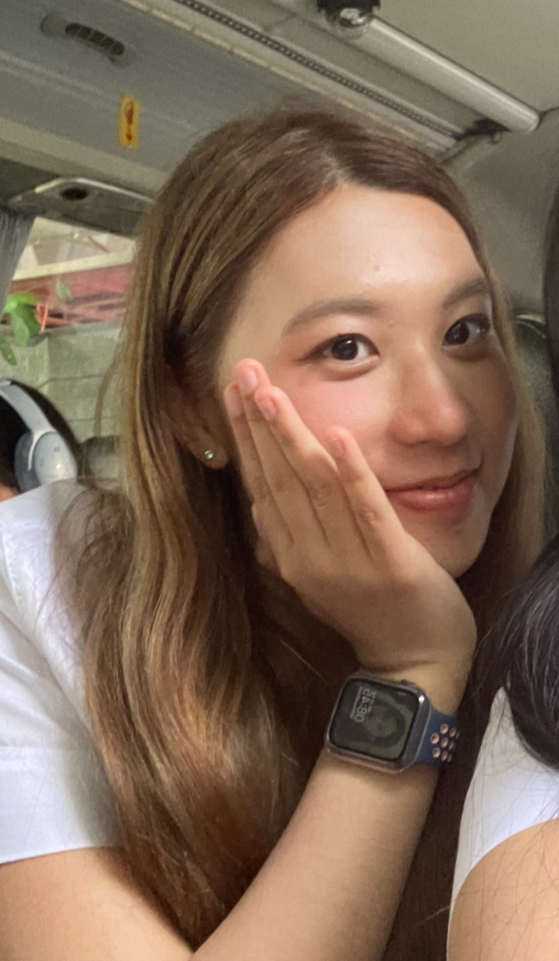

Natpraphat Snitwong Na Ayudhya (TANAT)

6848013024

My name is Pongkhun Kao-Ian or Khun for short, I studied kindergarden at Manasuksa School (2009 – 2013), primary school in both Hat Yai International School (2013 - 2015) and Anuban Yala School (2015 - 2019), then middle school in Saengthong Vitthayalai School (2019 - 2021), and high school in Abbey College Cambridge (2021 – 2025)

In the summer break of 2024, I was given the opportunity to work as an intern for the secretary to the governor of Bangkok in the Bangkok Metropolitan Administration. In that brief period, I came to understand the workings of local institutions and how they manage local problems, and inspections that they carried out helped give me a comprehension of the scope of the local government’s responsibility. Alongside this, I came to understand the schedule and lifestyle that Thai civil servants have and their workload. I have also seen democracy being put into practice, whether it be discussions by assembly members over local concerns.

I have so far entertained the ambition of becoming an MP in the Thai Parliament sometime in the future. I hope to do so because I want to improve the country and ensure better lives for people. Otherwise, I am also planning to work in a hedge fund managed by a friend of mine as a researcher whilst also considering studying in Oxford’s politics master’s degree in the future. In the immediate future, I am running an art account on Instagram right now and potentially expanding my artistic career by creating a comic book/manga series of my own that I would like to publish in the future.

For the longest time, I have had an interest in history and politics, and I have constantly noticed how interwoven with each other and other subjects such as economics as well and how important it is to do so. Hence, Chulalongkorn’s PGs programmed fulfill exactly this aspect.

History is because of how the past constructed the present and why we made the decisions that we made, and the trajectory which places a society on a certain path which perhaps can inform us of how the future would unfold. Meanwhile, politics is the art of constructing alliances and narratives, alongside utilizing existing institutions that would allow change to be made in the future. By understanding politics, we can shape the world to our ideal.

However, these fields do not exist in isolation as history requires politics to understand why people in the past made decisions the way they do. Whilst in politics, the creation of a narrative and deep understanding of an issue would require understanding of the past. Therefore, Chulalongkorn’s interdisciplinary approach fits well, as the combining of multiple field’s understanding would allow a clearer and precise picture of events that can be used to deal with real world problems in a more sufficient manner.

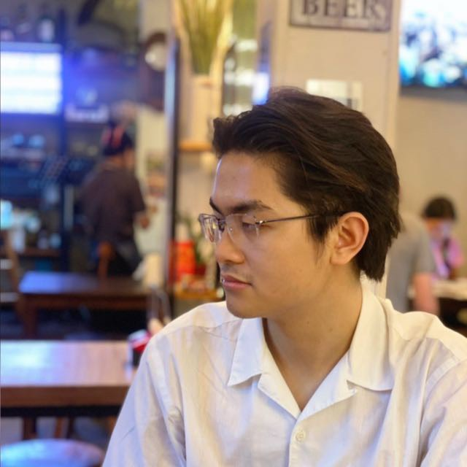

Pongkhun Kaoian (Khun) 6848028424